**POC Of Cheque Generation**

1. Read the Excel file.

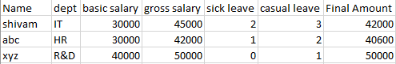

1. We have a template image of the cheque. And we are creating new image so there is no change in template image.

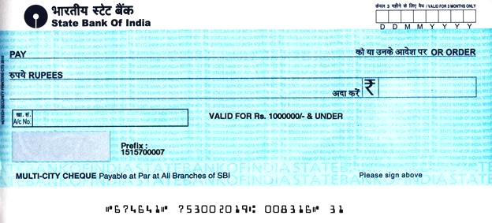

1. For each row in Data Table:
2. Convert the image into a bitmap

* Bitmap = new bitmap(ImagePath) : ImagePath = path of template image

1. Convert bitmap to graphics

* Graphics = Graphics.FromImage(bitmap)

1. Assign the Final Amount to Amount variable

* Amount = CurrentRow("Final Amount").ToString

1. Convert the Amount in Word through the activity (install dependency)
2. Invoke Code with parameters.

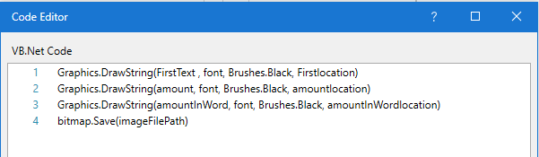

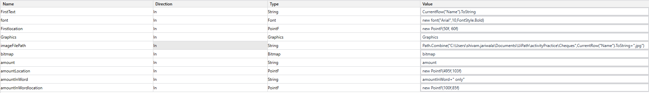

**Proof**



  
  
  
  
  